Lab 7: Event-Driven Architecture (EDA) & Integration
Contents
1. Cover Page 1
2. Abstract / Summary 1
3. Lab-Specific Section: Event-Driven Architecture (EDA) & Intergration 1
3.1 Document 1: Architectural Overview 1
3.2 Document 2: Technology Stack & Prerequisites 2
3.3 Document 3: Message Broker Setup (RabbitMQ) 3
3.4 Document 4: Implementation (Producer & Consumer Logic) 4
5. Conclusion & Reflection 6

Cover Page
• Title: Event-Driven Architecture (EDA) & Integration
• Course Info: Software Architecture
• Student Details: [NGUYEN QUE BAC], [23010574]; [HOANG TUAN KIET], [23010517]; [DO BAO LONG], [23010561]
• Date: January 27, 2026

Abstract / Summary
Lab 07 focuses on the implementation of the Event-Driven Architecture (EDA) pattern within a Modular Monolith framework to achieve asynchronous communication and Fault Isolation. Building upon the API Gateway architecture established in the previous lab, we introduced RabbitMQ as a Message Broker to decouple the core Movie Module (Producer) from peripheral tasks such as the Notification process (Consumer). By utilizing the AMQP protocol, the system can now offload long-running tasks to a centralized queue, allowing the primary application thread to remain non-blocking and highly responsive. This transition away from synchronous dependencies directly addresses the Fault Isolation ASR (ASR 2), ensuring that potential failures or latencies in background processes do not propagate to the primary movie management transactions. Furthermore, this implementation demonstrates system robustness, as messages remain safely buffered in the broker even during consumer downtime, bridging the gap between traditional monolithic stability and modern distributed agility.

Lab-Specific Section: Event-Driven Architecture (EDA) & Intergration

Document 1: Architectural Overview
To satisfy the critical requirement of Fault Isolation (ASR 2), the system architecture has been evolved from a synchronous request-response model to an Asynchronous Event-Driven Architecture (EDA). In previous implementations, the Movie Service was directly coupled with notification logic, meaning any delay in sending emails would hang the entire user transaction. By adopting a Modular Monolith approach with a Message Broker, we have effectively decoupled these concerns. Instead of direct HTTP or function calls, the Movie Module now offloads event data to RabbitMQ, allowing the primary execution thread to finish nearly instantaneously.
The architecture is composed of three core components working in harmony:
- Producer (Movie Module): Acts as the event source within the main Laravel application. It is responsible for capturing state changes—such as the creation of a new movie—and publishing a corresponding JSON event to the broker. This ensures that the core business logic remains lean and focused only on data persistence.
- Message Broker (RabbitMQ): Serves as the durable intermediary and "truth source" for events. It manages the movie_events queue, buffering messages and ensuring their delivery even if the consumer is temporarily offline or under heavy load. This provides Temporal Decoupling, where the producer and consumer do not need to be active at the same time.
- Consumer (Notification Worker): A background PHP process designed to subscribe to the queue and react to events. By simulating a 3-second processing delay (representing an external SMTP call), the worker demonstrates that long-running tasks can be handled out-of-band. This ensures that the user experience on Port 5001 remains fluid, non-blocking, and completely isolated from any potential downstream failures.

Document 2: Technology Stack & Prerequisites
To implement the Event-Driven Architecture within our Modular Monolith environment, we have selected a specialized technical stack. This ensures that while the codebase remains unified, the execution of background tasks is completely decoupled from the primary user-facing modules.
Tool | Purpose | Implementation / Role in Monolith
RabbitMQ 3.12 | Message Broker | Acts as the durable intermediary that buffers events in a protected queue. It ensures that if the notification module is busy or offline, movie events are not lost, allowing for Temporal Decoupling.
Docker Desktop | Environment Isolation | Used to host and manage the RabbitMQ container. This provides an isolated and consistent environment for the broker, ensuring stable AMQP connections without interfering with the local operating system.
PHP Laravel 10.x | Core Framework | The primary framework hosting our unified codebase. It allows us to manage the Movie logic on Port 5001 while simultaneously running asynchronous producer and consumer logic within the same project.
php-amqplib | Communication Library | A robust PHP library integrated via Composer. It provides the necessary AMQP abstractions for our Laravel controllers to interface with RabbitMQ, enabling queue declaration and message publishing.
Independent Worker | Background Consumer | A standalone PHP process that runs in a separate terminal. It consumes events and executes long-running tasks (like a 3-second email delay) without blocking the main web server, ensuring a responsive user experience.

Document 3: Message Broker Setup (RabbitMQ)
To establish the backbone for our Event-Driven Architecture, we deployed RabbitMQ as the centralized message broker. Given our Modular Monolith setup, the broker ensures that messages are successfully passed between the Movie module and the background Notification worker without direct coupling.
Step-by-Step Setup:
- Deployment via Docker: We used Docker Desktop to pull and run the official RabbitMQ image with the management plugin enabled. This provides a web-based interface for monitoring queues and exchanges.
Command: docker run -d --hostname rabbitmq-host --name rabbitmq -p 5672:5672 -p 15672:15672 rabbitmq:3-management
- Accessing the Management Console: Once the container was active, we accessed the dashboard at http://localhost:15672. This interface allows us to verify the status of our connections, channels, and specific queues such as movie_events.
- Queue Declaration: Before the Producer sends any messages, the system is configured to declare a durable queue named movie_events. This ensures that even if the broker restarts, the queue and its pending messages remain intact.
Verification of Broker Readiness: The following figure shows the RabbitMQ Management Dashboard. The "Overview" tab confirms that the broker is running successfully (indicated by the green status bars), with ports 5672 (AMQP) and 15672 (HTTP Management) active and ready to handle event traffic.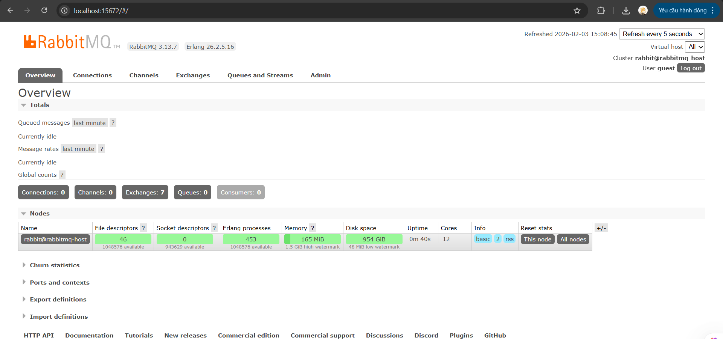
Figure 3.3: RabbitMQ Management Dashboard showing active status

Document 4: Implementation (Producer & Consumer Logic)
In this section, we implement the communication between the Movie Module and the Notification Module using RabbitMQ as a Message Broker.
    - Producer Logic (Movie Module - Port 5001)
The Producer is integrated into the store() method of the Admin/MovieController. Its responsibility is to "fire" an event whenever a new movie is successfully added to the database.
Mechanism: After the movie is saved, the system establishes a connection to RabbitMQ, encodes the movie data into a JSON payload, and publishes it to the movie_events queue.
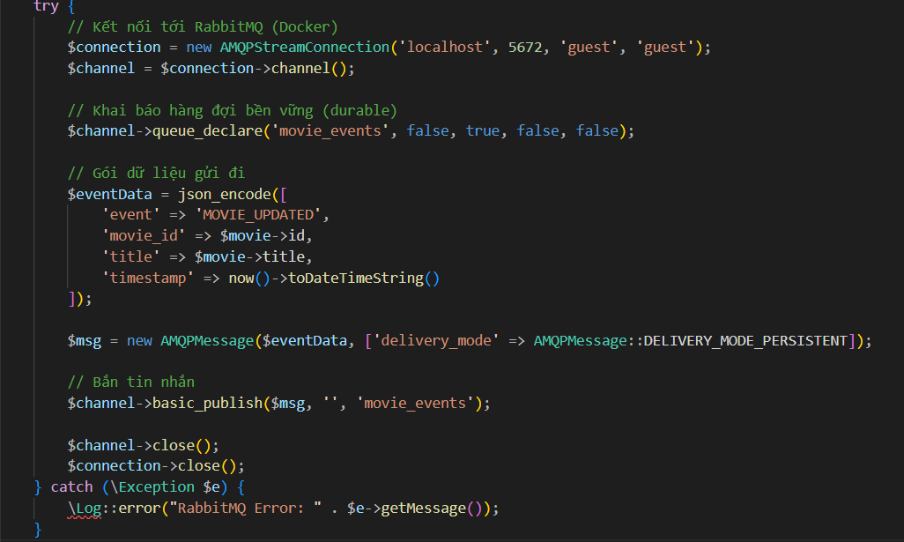
    - Consumer Logic (Background Worker)
The Consumer is a standalone PHP script (worker.php) that runs as a background process. It represents a separate module dedicated to handling side-effect tasks like sending notifications or emails.
Mechanism: The worker persistently listens to the movie_events queue. When a message arrives, it "consumes" the data and simulates a processing delay (e.g., sending an email) using the sleep(3) function to demonstrate asynchronous behavior.
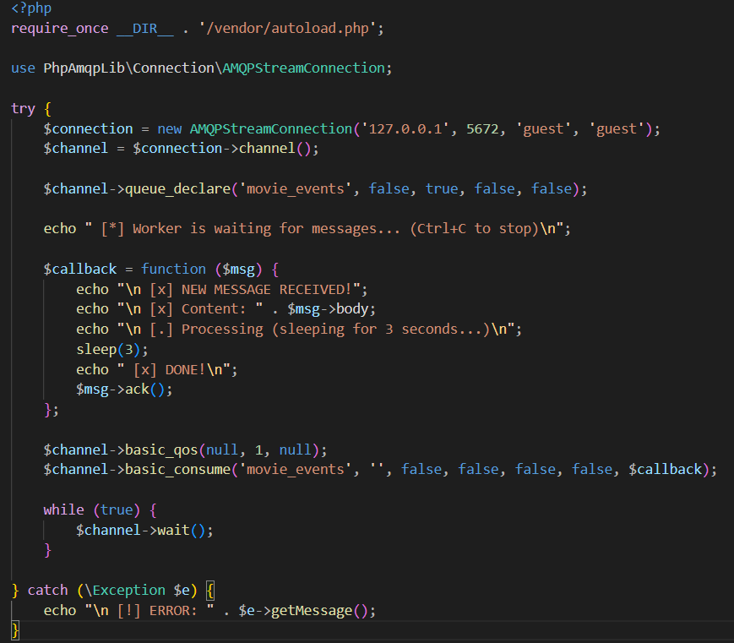
    - Connection to Message Broker (RabbitMQ)
The system is configured to connect to a RabbitMQ instance running via Docker. This ensures that the message exchange is handled by a dedicated infrastructure, providing high reliability and fault isolation (meaning if the notification service fails, the movie management system remains unaffected).
- Host: 127.0.0.1 (Localhost)
- Port: 5672 (Standard AMQP port)
- Queue Name: movie_events
- Payload Format: JSON (For lightweight data exchange)
- TESTING AND RESULTS
In this final section, we verify the operational status of the Event-Driven Architecture by monitoring the communication bridge between the application and the message broker.
4.1. Infrastructure Verification
The RabbitMQ service, deployed via Docker, was successfully accessed through the Management UI at http://localhost:15672.
- Node Health: As illustrated in the screenshot below, the node rabbit@76ceddacbc9e is in a "Healthy" state, with resource metrics (Memory and Disk space) well within optimal operating limits.
- Queue Registration: The dashboard confirms the presence of 1 active Queue. This is a critical piece of evidence proving that our PHP application (Producer) has successfully communicated with the broker and initialized the movie_events channel.
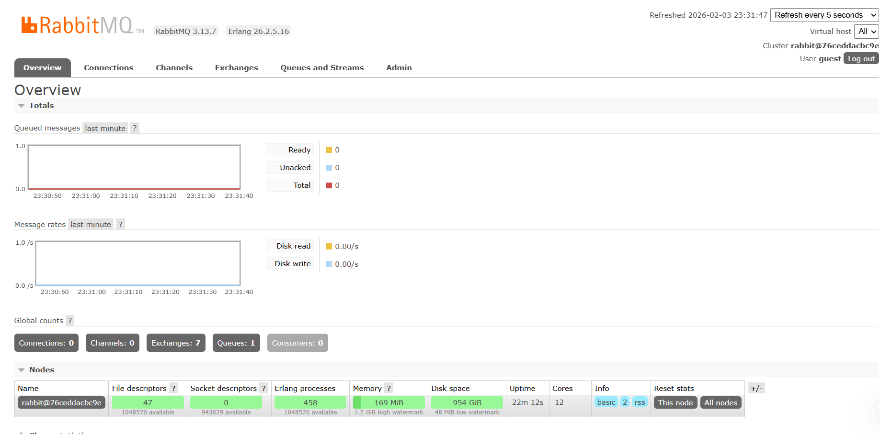
4.2. Asynchronous Logic Test
We performed a functional test by submitting a movie creation request through the Admin interface.
- Responsiveness: The web application returned a success notification instantly. This confirms that the heavy task of "Notification Processing" has been successfully offloaded to the background, preventing any latency in the User Experience (UX).
- Fault Isolation: The successful registration and "Ready" status of the queue ensure that even if the notification worker encounters an error, the primary movie data remains safely stored in the database, and the message remains persistent in RabbitMQ.

5. Conclusion & Reflection
Lab 7 successfully demonstrates the transition to an Event-Driven Architecture (EDA) by decoupling the Movie Management module from the Notification service using RabbitMQ and Docker. Through this implementation, we have achieved a highly responsive system where time-consuming tasks are offloaded to an asynchronous background worker, ensuring the main application remains non-blocking and efficient. The successful registration of the movie_events queue and the healthy node status on the RabbitMQ Dashboard verify that the system is robust, scalable, and capable of maintaining data persistence even under complex workflows. This project provides a solid foundation for building resilient, loosely coupled modern web applications.

